**Report HW 2 ECE-111**

Name: Jasper Huang

PID: A17796149

# **Homework 2a (4-bit ALU)**

1. **SystemVerilog code snapshot**
   1. **alu_top**

* 1. **alu**

1. **Provide snapshot of FPGA resource usage generated post synthesis**A screenshot of a computer

   AI-generated content may be incorrect.
2. **Provide snapshot of schematic generated from RTL netlist viewer**A diagram of a green rectangle

   AI-generated content may be incorrect.
3. **Provide snapshot of simulation waveform and explain simulation result**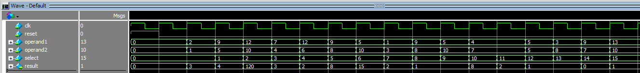

The simulation graph shows the clock tick and after the reset flagged, the operand1 and operand2 began to perform based on the selected operation (determine by the select logic) and result changes based on the operation result from operand1 and operand2. For each of the select, the result matches the expected operation which for example, select 0 is addition, which 2 + 1 = 3 matches the result 3.

# **Homework 2b (4-bit up down binary counter)**

1. **SystemVerilog code snapshot**
   1. **up_down_counter**

* 1. **up_counter**

* 1. **down_counter**

* 1. **mux_2x1**

1. **Provide snapshot of FPGA resource usage generated post synthesis A screenshot of a computer

   AI-generated content may be incorrect.**
2. **Provide snapshot of schematic generated from RTL netlist viewerA diagram of a computer program

   AI-generated content may be incorrect.**
3. **Provide snapshot of simulation waveform and explain simulation result**

The simulation waveform shows a count_value changing at each positive edge of clk where the counting value changes depending on either select 0 which is count_up from 0 to 15 or count_down which is from 15 to 0. The presented waveform shows we first clear and select count up, which you can see 0 to 15, and then after second clear, the count down is selected which shows 15 to 0.